REPORT PROPERTIES

Properties:
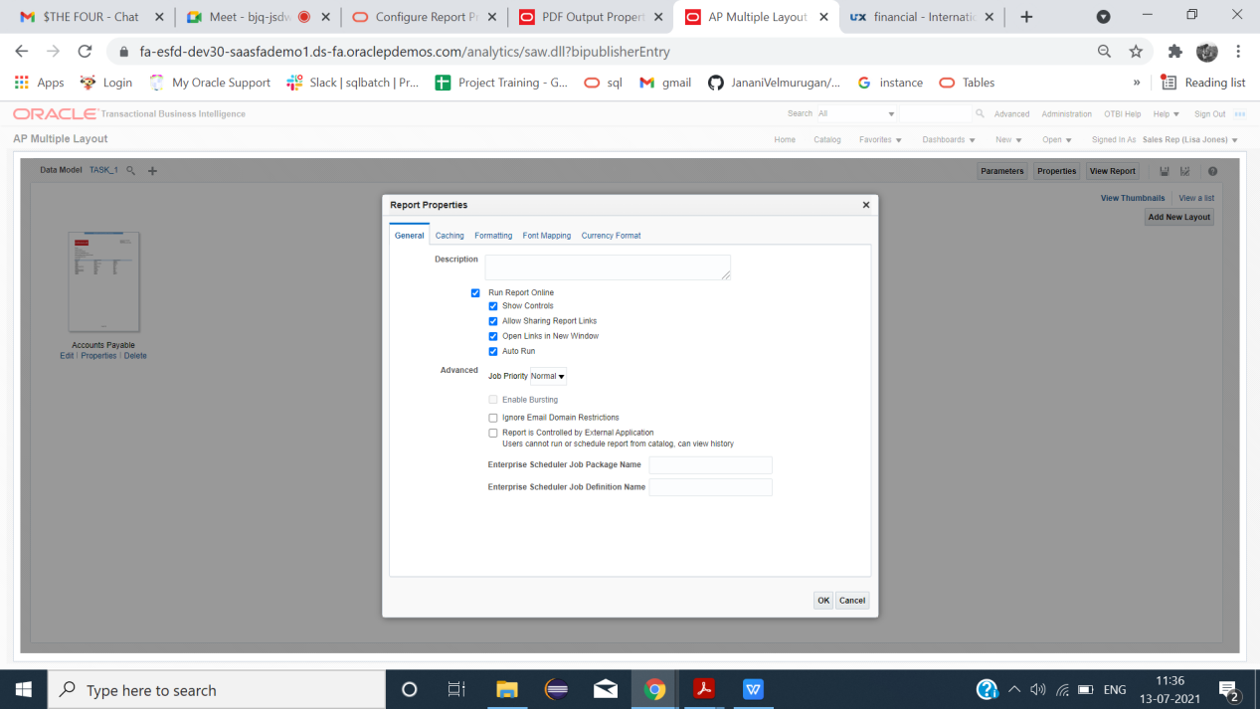

GENERAL:
Description

 | 

Run Report Online
When we enable Run report online it generates the report in online
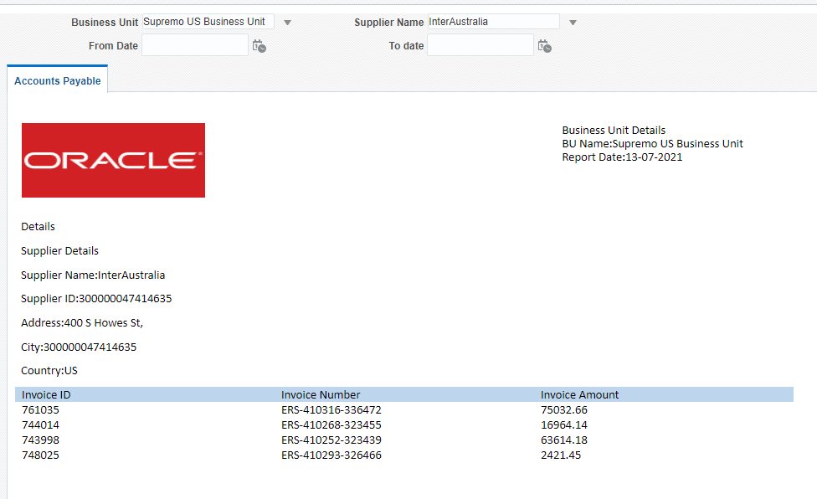

When we disable Run report online it does not generate the report in online.

Show controls
Enable: Disable:
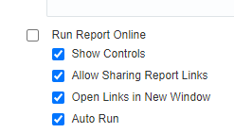 | 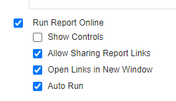

 | 

Allow Sharing Report Links
Enable: Disable:
 | 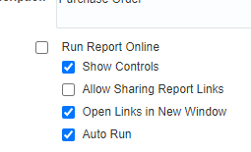
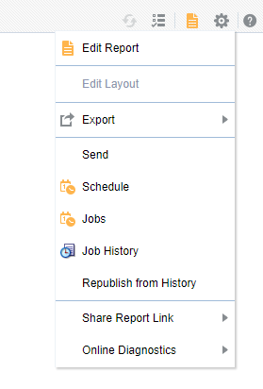 | 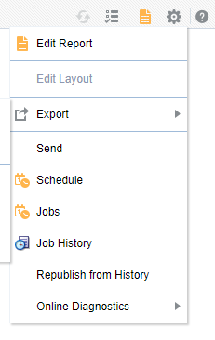

Open Links In New Window
If we have any links in our report we have two methods
1.) If we want to open In new window

2.) If we want to open In Same window
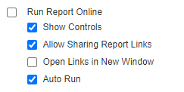

Job Priority
- Used to assign priority for the reports as critical, normal and low (by default normal).
- It is used to schedule the report based on the priority.
- First In First Out method is used when all the reports having same priority.
Enable Bursting
Used to enable bursting on the report. If it is disabled, we can’t schedule the report using bursting.
Ignore Email Domain Restrictions
It is used to ignore the email domain set in the Allowed Email Recipient in the Delivery Configuration page.
(Administration-->BI publisher(Manage BI publisher)-->Delivery(Delivery Configuration)
Report controlled by External application
- If this enabled, the report is controlled by the external application which is integrated with the publisher and we can’t able to run or view the report.
- Report is run by publisher and stored in the Publisher History Tables.
- Completed reports are viewed from the Report job history page.

Catching:
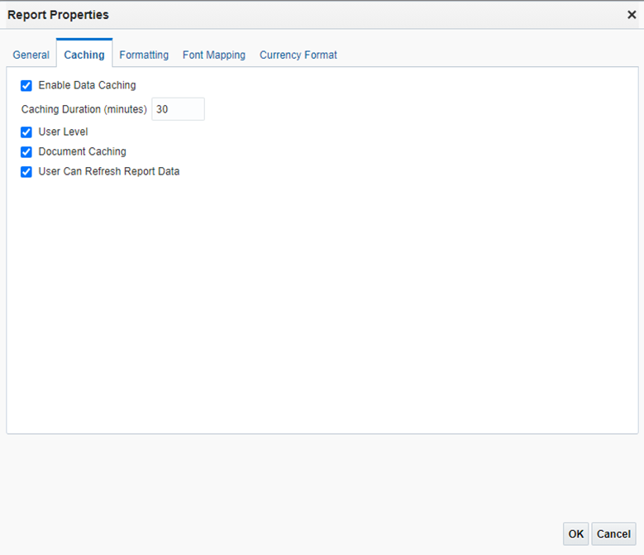

Enable data catching:(Default: not enabled)
- Data generated in online stored in cache when we run the same report (with same parameter) it will not regenerate data from source.
- It will take it from cache.
- Caching Duration (Minutes): cache hold data for a specific time mentioned here.

User Level:(default:30 min)
Separate cache for each user.

Document cache: (default:enabled)
Cache report document.When user view report in online it stored in cache,when another user view the same document(with same parameter) in same online viewer it will take it from cache(user who viewed first) and it will not regenerate from source.cache holds data according to caching duration.

User Can Refresh Report Data:(default: not enabled)
User clicks refresh in report viewer,BI publisher generate a fresh data set for the report.

FORMATTING:
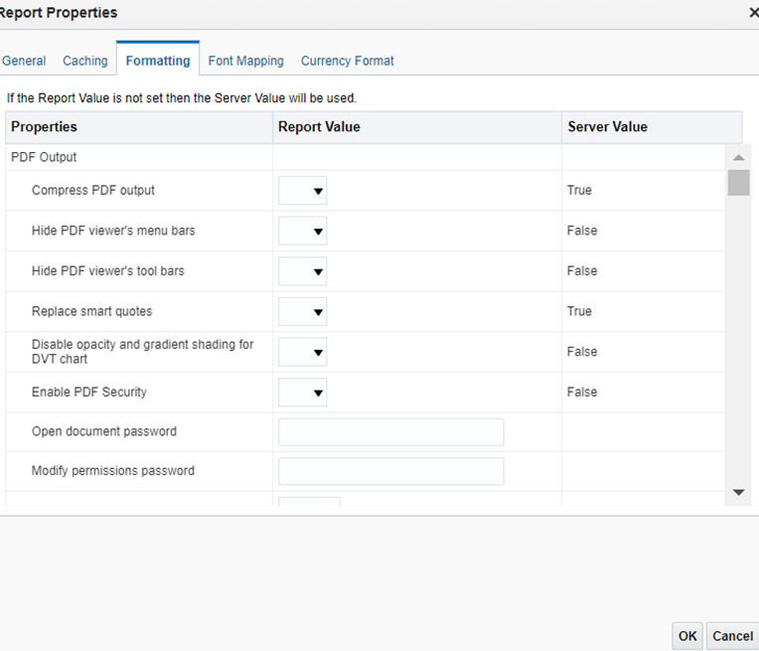

Compress PDF output:(default:true)
Compress the output PDF file(downloaded).
TRUE:(default)FALSE:

Hide PDF viewer's menu bars: Default: false
Hide menu bar(export -> PDF) in standalone Acrobat Reader application outside of the browser.
FALSE:
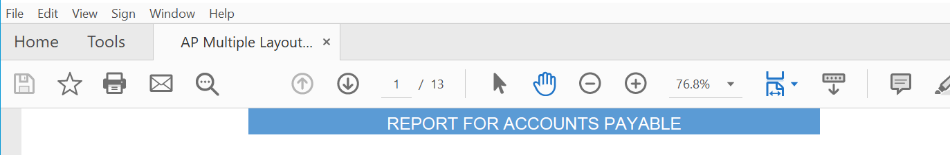

TRUE:
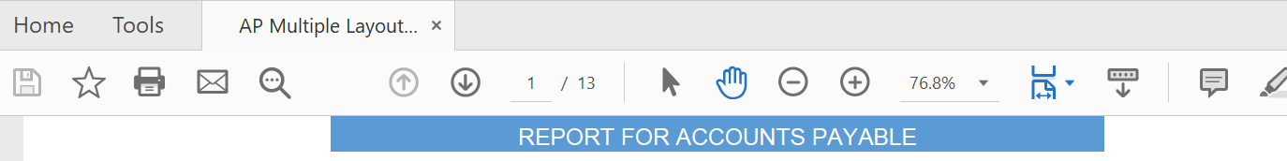

Hide PDF viewer's tool bars(Default: false)
It will hide the toolbar option when document is active.
FALSE:
TRUE:
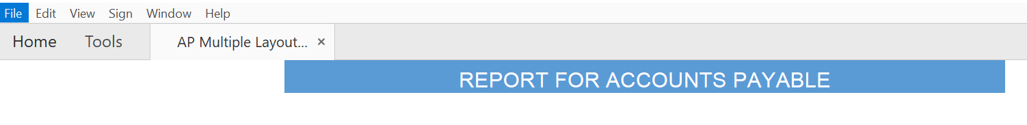Replace smart quotes:Default: true
Curly quotes are not replaced by straight quotes in PDF output.
Enable PDF Security:Default: false
The output PDF file is encrypted.

TRUE:
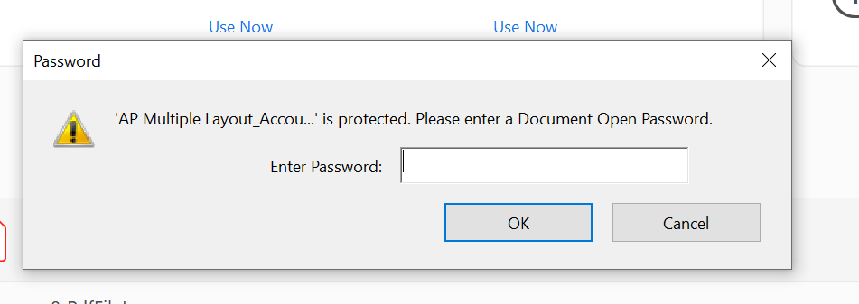

Properties under enable PDF security:
- Open document password
- Modify permissions password
- Encryption Level
Open document password:Default:
Password is required to open this document file.
Modify permissions password:Default: N/A
Password enables users to override the security setting.

Encryption level: Default: 2 - high
The encryption level for the output PDF file. The possible values are:
- 0: Low (40-bit RC4, Acrobat 3.0 or later)
- 1: Medium (128-bit RC4, Acrobat 5.0 or later)
- 2: High (128-bit AES, Acrobat 7.0 or later)
When Encryption level is set to 0, you can also set the following properties:
- Disable printing
- Disable document modification.
- Disable context copying, extraction, and accessibility
- Disable adding or changing comments and form fields.
When Encryption level is set to 1 or higher, the following properties are available
- Enable text access for screen readers
- Enable copying of text, images, and other content
- Allowed change level
- 0: none
- 1: Allows inserting, deleting, and rotating pages
- 2: Allows filling in form fields and signing
- 3: Allows commenting, filling in form fields, and signing
- 4: Allows all changes except extracting page.
- Allowed printing level
- 0: None
- 1: Low resolution (150 dpi)
- 2: High resolution

HTML Output:
Show header
It suppress the template header in HTML output when set to false.

Show footer
It suppress the template footer in HTML output when set to false.

Replace smart quotes
Set to "false" if you don't want curly quotes replaced with straight quotes in the HTML output.

Character set
It Specify the output HTML character set. (EX:UTF-8)

Make HTML Output accessible
Set to "true" to make the HTML output accessible.

Use percentage width for table columns
It is useful if the browser display tables with extremely wide columns. Setting this property to true improves the readability of the tables.

View Paginated
When you set this property to true, HTML output will render in the report viewer with pagination features. These features include:
- Generated table of contents
- Navigation links at the top and bottom of the page
- Ability to skip to a specific page within the HTML document
- Search for strings within the HTML document using the browser's search capability
- Zoom in and out on the HTML document using the browser's zoom capability
Note that these features are supported for online viewing through the report viewer only.

Reduce Padding in Table-cell
When we set true to this property, it displayed without padding, which maximizes the page space available for text.

Embed images and charts in HTML for offline viewing
When we set true, charts and images are embedded in the HTML output, We can view in offline.

Use SVG for Charts
- When we set this property to true, charts display as a SVG (Scalable Vector Graphic) to provide a higher resolution in the HTML output.
- Otherwise, charts display as a raster image.

Keep original table width
When we set true to this property, the original width of the table is maintained.

HTML and CSS embedding
This property consists of embedded css in html header,
External css file,embedded css in html element.

Enable horizontal scrollbar automatically for html table
When you set this property to true, a horizontal scroll bar is added to a table.
Enable html table column size auto adjust
When we set true to this property, column widths in a table are automatically adjusted to the size of the browser window.
RTF Template
Extract Attribute Sets
It is used to extract attribute set within the XSL -FO. It has 3 options listed below.
- Enable - Extract all from Templates and Sub-templates.
- Auto (Default) - Extract only from Templates.
- Disable - Do not extract attribute sets.
Enable XPath Rewriting
- RTF processor automatically converts all the XML tag names full XPath notations during the conversion of RTF template to XSL - FO.
- Make the option false to disable this property.

Character used for checkbox
Used to represent the checkbox during the PDF output which include a glyph.

XPT Template Properties
Enable Asynchronous mode for interactive output
- True - Interactive report makes asynchronous calls to Oracle WebLogic Server.
- False - Interactive report makes synchronous calls to Oracle WebLogic Server
- which limits number of calls and any calls are expired in 600 sec.

XPT Scalable mode
- True - Scheduled reports runs without memory issues as it stores first 100000
- rows in memory and remaining in file system.
- False - It raise memory issue as it only uses the in-memory.

PDF Form Templates
Remove PDF fields from output
Remove PDF fields from output and we can’t extract data from the fields. For repeating fields it must be true and we can’t able to change it to false.

Set all fields as read only in output
- True - Read only for the fields in output.
- False - Updatable for the fields in output.
✓ Maintain each field’s read only setting
Enable to maintain read only setting for each fields.

Excel Template properties
Enable Scalable mode
Used to solve the memory issue by making multiple sheets when more than 65000 rows (max in MS Excel) are used in the report.

Flash Template Properties
Page width of wrapper document
Width of the PDF output document in points.

Page height of wrapper document
Height of the PDF output document in points.
Start x position of flash area in PDF
Beginning horizontal position of the flash object in the PDF document in points.

Start y position of flash area in PDF
Beginning vertical position of the flash object in the PDF document in points.

Width of flash area
Width of the document area of the flash objects.

Height of flash area
Height of the document area of the flash objects.

CSV Output properties
CSV Delimiter
Specifies the character used in the comma separated value output.
Remove trailing and leading white space
If true, it removes the white spaces in the data and delimiter.

EXCEL 2007 Output
Show grid lines
If we set true, it shows the excel table grid lines in the report output.
Page break as a new sheet
When we set true to this property, it generates a new sheet in the Excel workbook.
Minimum column width
- When the column width is less than the specified minimum and it contains no data, the column is merged with the preceding column.
- The value must be set in points. The valid range for this property is 0.5 to 20 points.

Minimum row height
- When the row height is less than the specified minimum and it contains no data, the row is removed.
- The value must be set in points.
- The valid range for this property is 0.001 to 5 points.

Keep values in same column
When we set true, it minimize column merging.

Open password
In this property to specify the password that the users must provide to open any XLS output file.

Table Auto Layout
- Here we Specify a conversion ratio in points and a maximum length in points, Example 6.5,150
- For this property "Keep values in same column" must be set to True.
- It expands the table column width to fit the contents.
- The column width is expanded based on the character count and conversion ratio up to the maximum specification.

ETEXT OUTPUT
Add UTF-8 BOM Signature
When set to true, the Etext output is in UTF-8 Unicode with BOM(BYTE ORDER MARK) form.

FONT MAPPING
- We can map base fonts in RTF or PDF templates to the target fonts to be used in the published document.
- Font mapping is performed only for PDF PowerPoint output.
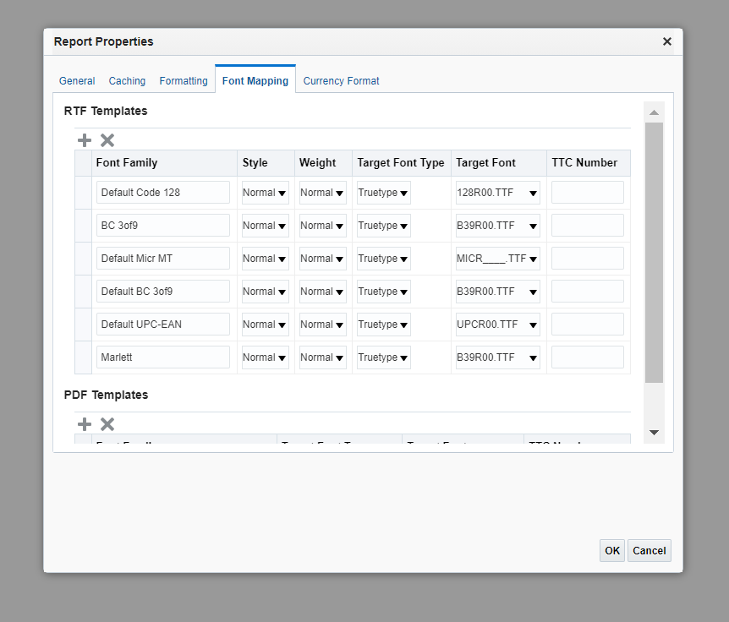

Types of Font Mappings:

RTF Templates
For mapping fonts from RTF templates and XSL-FO templates to PDF and PowerPoint output fonts.
PDF Templates
For mapping fonts from PDF templates to different PDF output fonts.
To create a Font Mapping:
- Under RTF Templates or PDF Templates, select Add Font Mapping.
- Base Font - enter the font family that is mapped to a new font.
- Example: Arial
- Select the Style: Normal or Italic (Not applicable to PDF Template font mappings)
- Select the Weight: Normal or Bold (Not applicable to PDF Template font mappings)
- Select the Target Font Type: Type 1 or TrueType
- Enter the Target Font
- If you selected TrueType, then you can enter a specific numbered font in the collection. Enter the TrueType Collection (TTC) Number of the desired font.

CURRENCY FORMATTING:
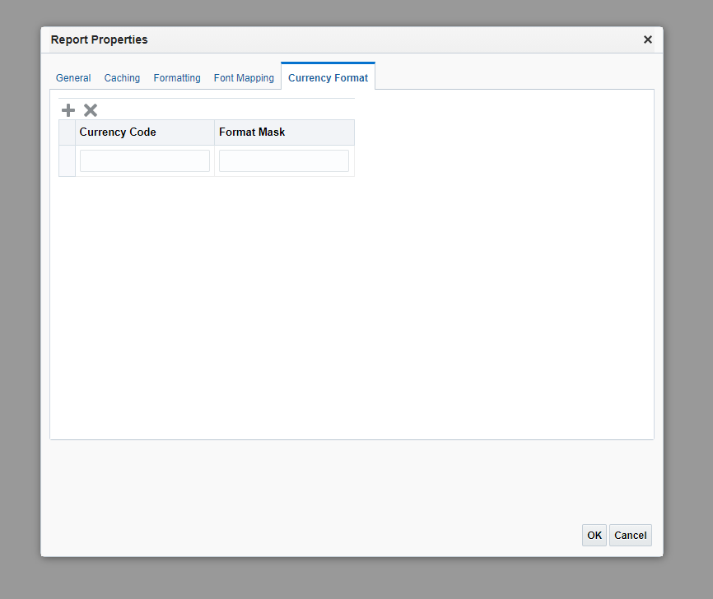
In the Currency Format tab, map a number format mask to a specific currency so that reports can display multiple currencies with their own corresponding formatting.
To apply these currency formats in an RTF template, we must use the format-currency function.
- Click the Add icon.
- Enter the ISO currency code, for example: USD, JPY, EUR, GBP, INR.
- Enter the format mask to apply for this currency.
- The Format Mask must be in the Oracle number format. The Oracle number format uses the components "9", "0", "D", and "G" to compose the format, for example: 9G999D00

Here,
- 9 represents a displayed number only if present in data
- G represents the group separator
- D represents the decimal separator
- 0 represents an explicitly displayed number regardless of incoming data

